***NPM Assignment***

#### 

|  |  |
| --- | --- |
| Representative : | Sumit Singh |
| Emp ID : | 1561 |
| Issued by : | Knoldus Inc. |
| Installation Process : | Aug 20, 2021 |
| Page count : | 8 |

**Requirement :**

Setup NODEjs environment in your machine and install the following packages as global packages -

1. Angular

2. React

3. Vue

4. Ionic

# **Introduction :**

NPM(Node Package Manager) is package manager for node JavaScript platform. Its puts modules in place so that node can finds and manages commonly it is used to publish, discover ,install and develop node programs.

**Nodejs Installation :**

**I have installed the latest version of nodejs. if you want to install the latest version go to this link -**

[**https://github.com/nodesource/distributions/blob/master/README.md**](https://github.com/nodesource/distributions/blob/master/README.md)

* Copy these commands and run it in your terminal.
* **curl -fsSL https://deb.nodesource.com/setup_16.x | sudo -E bash -**

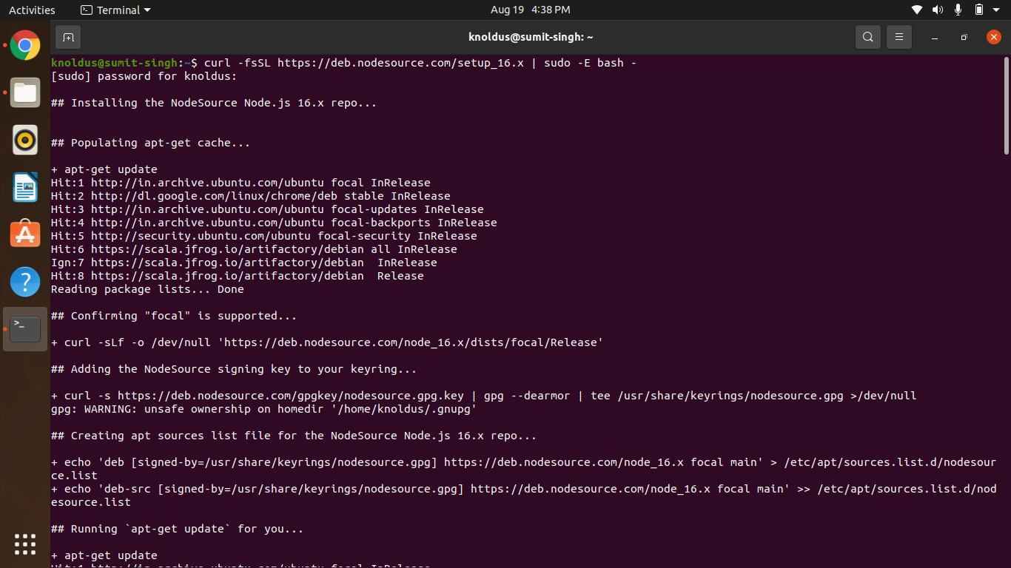

* **sudo apt-get install -y nodejs**

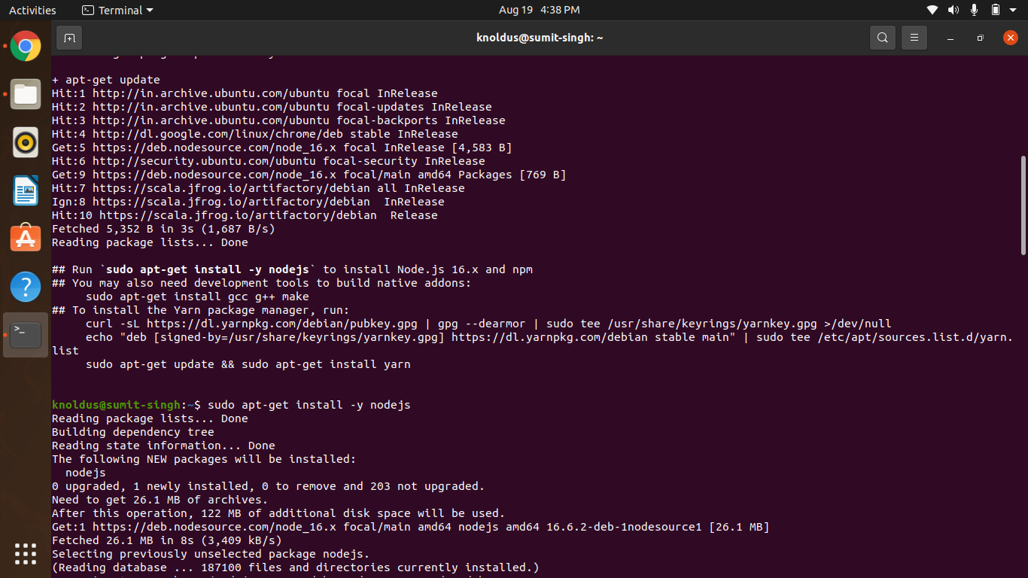

**Angular Installation :**

* **Run the given command in your terminal.**
* **npm install -g @angular/cli**

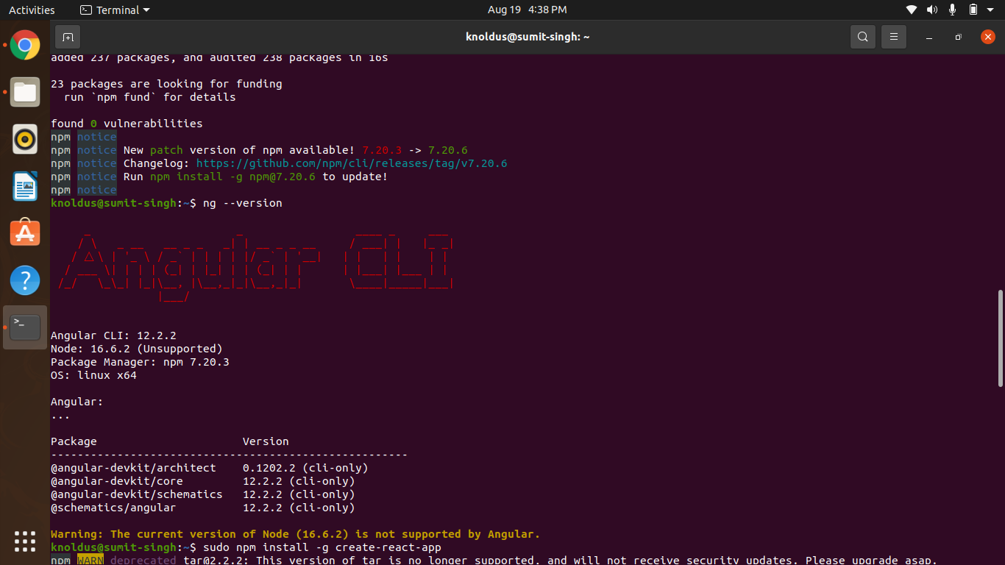

* Now check the version for successful installation of angular by below command.
* **ng --version**

**React Installation :**

* **Run the given command in your terminal.**
* **sudo npm install -g create-react-app**

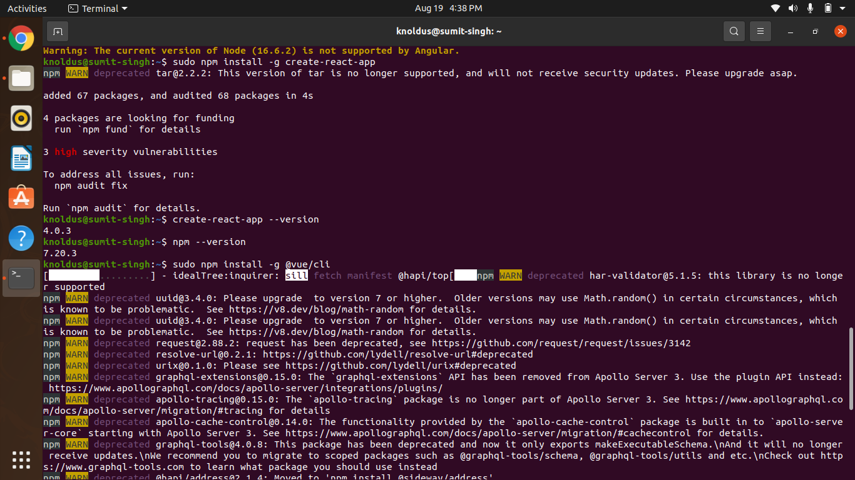

* Check the version for successful installation of react by running the below command.
* **npm --version**

**Vue Installation :**

* **Run the given command in your terminal.**
* **Sudo npm install -g @vue/cli**

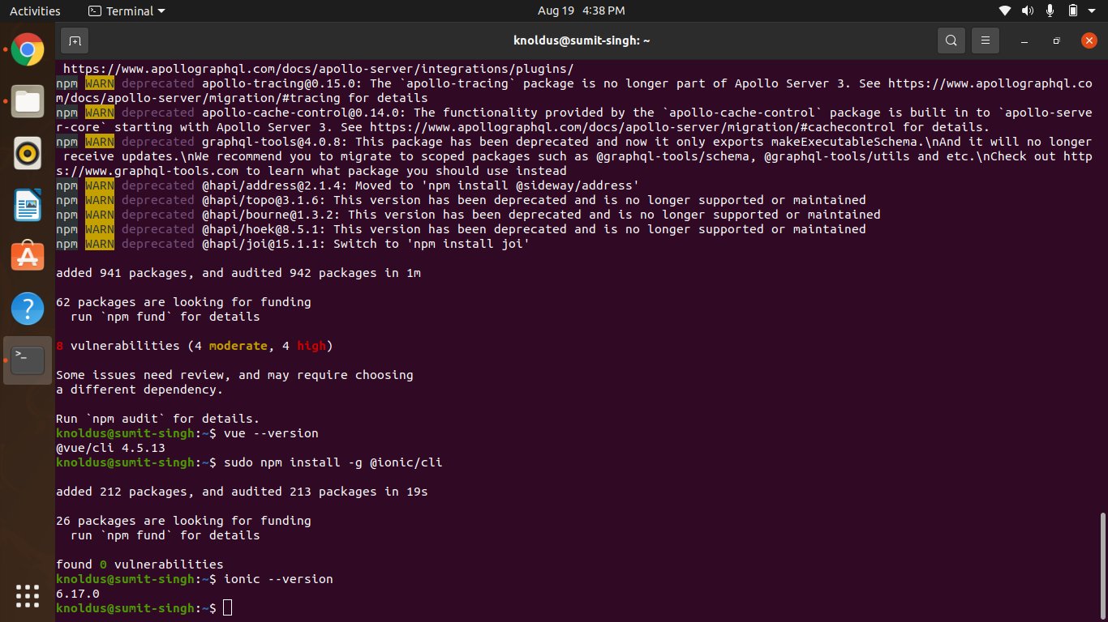

* Check the version for successful installation of vue by running the below command.
* **vue --version**

**Ionic Installation :**

* **Run the given command in your terminal.**
* **Sudo npm install -g @ionic/cli**



* Check the version for successful installation of vue by running the below command.
* **ionic --version**